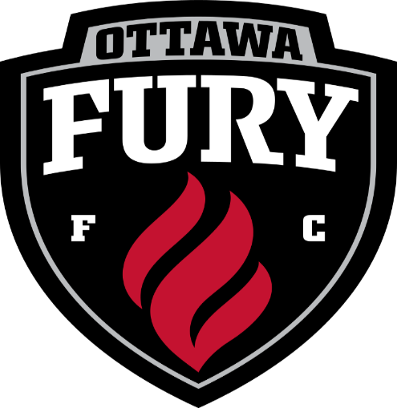

Coaches
We have a great opportunity to team up with the Ottawa fury and have a Russell Day at the match on July 15th, 2017. If you would like your team to participate in some of the on field activities that are listed below please contact Michelle no later than June 12th, 2017 at soccerisfun4life@gmail.com.

Player escorts, Guard of honor, pre-game mini team, half-time mini team shake the banner and ball retrievers

Based upon availability and first come and first serve.

